**Proposal for**

SUMMER UNDERGRADUATE RESEARCH AWARD (SURA) – 2016

Design and Fabrication of

Semiautonomous Robot as a Research Platform



**Rohit Patel Amal George**

Dept. of Mechanical Eng. Dept. of Physics

2014ME20757 2014PH10784

Contact No: 09650854161 Contact No: 09891050229

CGPA: 8.3 CGPA: 7.6

**FACILITATOR**

  Prof. Santanu Chaudhury

Professor   
Department of Electrical Engineering   
Indian Institute of Technology Delhi

**INTRODUCTION**

Neural networks are recommended for intelligent control as a part of well known structures with adaptive critic. Recently, the neural network-based control of mobile robots has been the subject of intense research. It is usual to work with kinematic models of mobile robot to obtain stable motion control laws for trajectory following or goal reaching.

We will be using neural network for controlling the mobile robot with non-holonomic constraints. This network is trained for recognizing obstacle that the bot can overcome and returning control to the master if it comes across one it cannot overcome. Thus this will not be a completely autonomous, but a semi-autonomous robot which will have huge applications in places where bot has to navigate through an unknown environment. It can be used for moving on predefined path or for mapping of foreign environment etc.

The Neural Network of the bot will be able to recognize known obstacles, which are “taught” during the training period, and overcome them. When an unknown object is encountered the robot will ping the user about the novel obstacle.

If possible the project is to be extended such that the bot will learn how to overcome an obstacle for the master control and use the information for next obstacle while following a predefined path.

**OBJECTIVE**

* Develop an operational, semiautonomous mobile robot
* Make a detailed CAD model of the bot for rough terrains
* Fabricate mechanical structure of robot
* Develop electrical circuit for detection of surroundings with appropriate sensor selection
* Develop a Neural Network model for obstacle detection and planning further action(return of control to user)

**APPROACH**

* Mechanical

The initial part of the project will be designing mechanical body of the robot with the help of CAD modelling software and its complete force analysis for travelling on rough terrains.

Next part includes manufacturing and fabrication of individual mechanisms and chassis.

* Electrical

Next section includes installation and calibration of various sensors like IR sensors (for line following), proximity sensor (for object detection) and different drivers e.g. Sabertooth (for motor control) etc.

* Programming

Development of a neural network for our specific purpose will be our next step. This will include studying existing models of neural network for related purpose. Modifying the network to transform it from autonomous to semiautonomous bot.

Next we will train the neural network for various environments. This will include subjecting the bot to obstacle of various sizes. Finding out if it can cross it or not and learning its solution.

Finally we will test it on an alien environment

**APPLICATION**

These types of robots are very essential in the industries where picking and placing of objects is required. Pick and place type of tasks include transfer of the objects from one assembly line to other (as in automobile industries), packing of products. A robot for this task reduces cycle time thus increasing production rates, also reduces chances of errors, and reduces human interference in the process. These pick and place robots are more accurate and do not fatigue while doing back-breaking or hard to maneuver movements that may be difficult for humans. An increase in output with a pick and place robot system offer long-term savings to companies. With the advancements in technology and affordability of robots, more pick and place robotic cells are being installed for automation applications. Pick and place robots can be manipulated easily to perform multiple applications. They just need to be re-programmed and tooled appropriately. This makes it possible for production unit managers and owners to accomplish myriad assembling tasks with one robotic system. From enabling businesses to produce on a large-scale to streamlining the work process and from increasing productive capacity to making the production line more efficient, these systems ultimately bring in riches for a business, both in terms of expanding business possibilities and increasing customer satisfaction.

**DURATION**

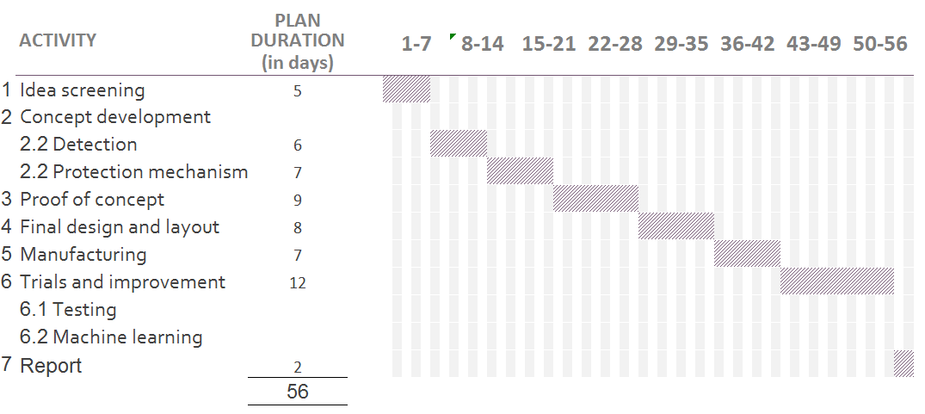

**BUDGET**

| S. No. | component | Estimated cost (INR) |
| --- | --- | --- |
| 1. | Accelerometer and Gyroscope module | 475 |
| 2. | Beaglebone (microprocessor) | 4000 |
| 3. | Interlaced wave springs [8] | 400 |
| 4. | Pre-owned android phone | 3000 |
| 5. | Micro motors | 800 |
| 6. | Microcontroller | 175 |
| 7. | Miscellaneous | 2000 |
|  | Total | 10850 |

**FACILITIES REQUIRED**

Accelerometer and proximity sensor from vibration lab or design lab

Access to labs of mechanical, electrical and electronics department

Access to CAD modeling (solidworks)

We will be requiring 3D printing and circuit designing facilities like PCB printing, soldering etc.

**REFERENCES**

[1] http://roboticsclub.iitd.ac.in/robomuse.html

[2] http://en.wikipedia.org/wiki/Industrial_robot

[3] http://www.robots.com/applications/pick-and-place

[4] http://www.bastiansolutions.com/robotics/robotic-solutions/pick-and-place-robotics

[5] http://www.iso.org/iso/iso_catalogue/catalogue_tc/catalogue_tc_browse.htm?commid=54138

[6] http://www.iso.org/iso/home/store/catalogue_tc/catalogue_detail.htm?csnumber=22244